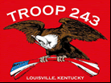
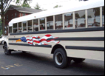
TROOP 243
August 1st, 2010
Boy Scouts of America
Chartered by St. Barnabas Catholic Church

3044 Hikes Lane Louisville, Ky 40220
http://www.troop243.com

Dear Parents and Friends of Troop 243,

Troop Outings & Activities – August begins with our 100th anniversary Jamboree contingent returning. August 8th is our all important Annual planning meeting followed by our annual Bishop Flaget Trail outing that will include tours of 3 churches of significance in the area of Mt. St. Francis Monastery. There will be 3 Pope Pius XII meetings and our Troop 243 anniversary Court of Honor. Of course we wrap up the month with our monthly leadership meetings.

Troop and Patrol Meetings on Wednesdays - All are welcome. Scouts in Class A uniforms are expected. Except where noted, all meetings are held at St. Barnabas.
August 4th, 7:00 PM – Troop Meeting – Patrol Spirit
August 11th, 7:00 PM – Patrol Meetings
August 18th, 7:00 PM – Troop Meeting - Patrol Spirit
August 25th, 7:00 PM – Troop Meeting moved to Saturday August 28th
August 28th, 4 – 9 PM - Anniversary Court of Honor

New Merit Badges – After a three-year drought, the BSA has been rolling out new merit badges at a fairly rapid pace in the past year. Scouts will soon have five additional merit badges to choose from. The topics of the new badges demonstrate the broad range of learning opportunities Scouting offers. Here’s a rundown on the status of the new badges: • Scuba Diving hit Scout shops in December. • Scouting Heritage appeared in April. • Inventing was officially unveiled at MIT in late June. • The Geocaching merit badge pamphlet is currently in review and should be released in early August. • Robotics is set to appear in 2011.
The requirements for the new badges are appearing at http://www.scouting.org/scoutsource/ BoyScouts/AdvancementandAwards/ MeritBadges.aspx as they are released.
Want more information?
Visit www.meritbadge.org. This unofficial site provides extensive resources related to every merit badge (new and old), including links to related websites and Wikipedia articles, connections to other Scouting awards on badge topics, and worksheets Scouts can use in working toward merit badges.

Historical Merit Badges – Four merit badges have been brought back temporarily to allow scouts to earn them before they go back into retirement. Carpentry, Pathfinding and Tracking were all discontinued in 1952. Signaling was discontinued in 1992. They will all four be retired again at the end of 2010 so if you want to get merit badges that will be awarded to very few, the time is now to earn it.
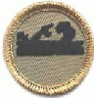
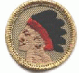
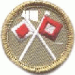
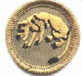
The actual badges are to the left in this order.
Carpentry, Pathfinding, Signaling and Tracking (previously called “Stalker” in 1911.)

Order of the Arrow – The next Order of the Arrow ordeal weekend will be August 27, 28 & 29. Some of our guys well be completing their ordeal as well as joining the brotherhood this weekend.

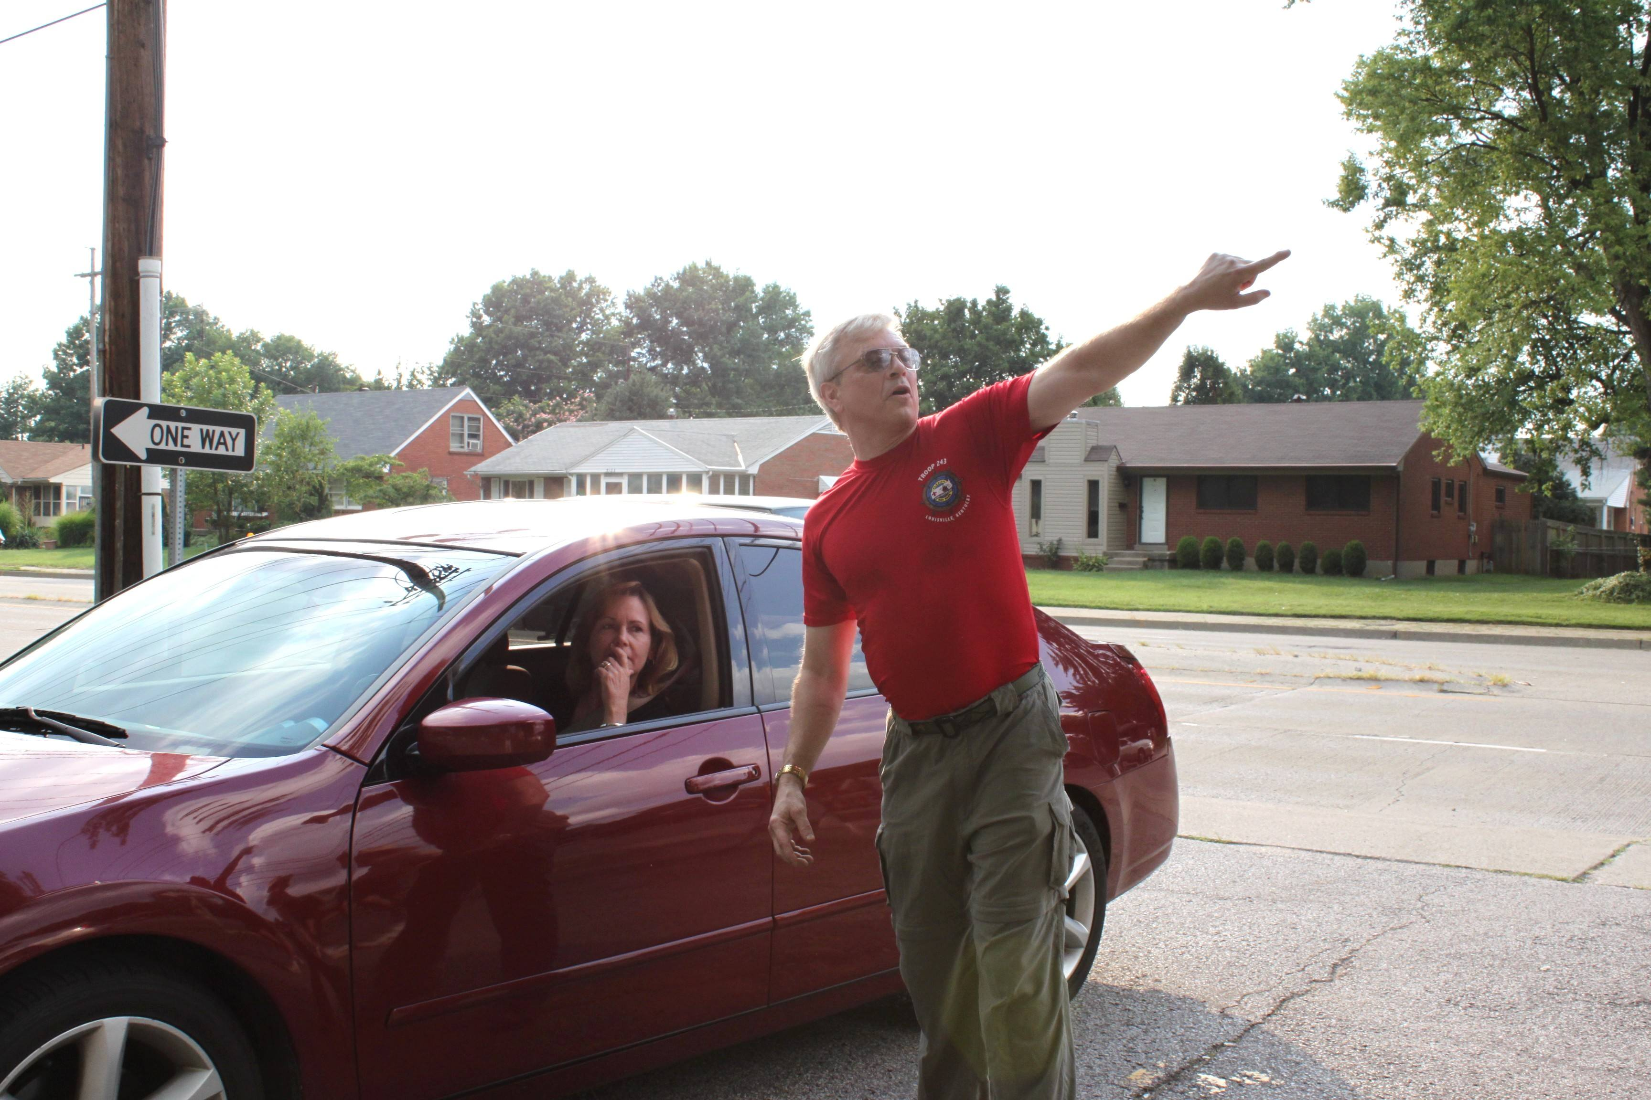
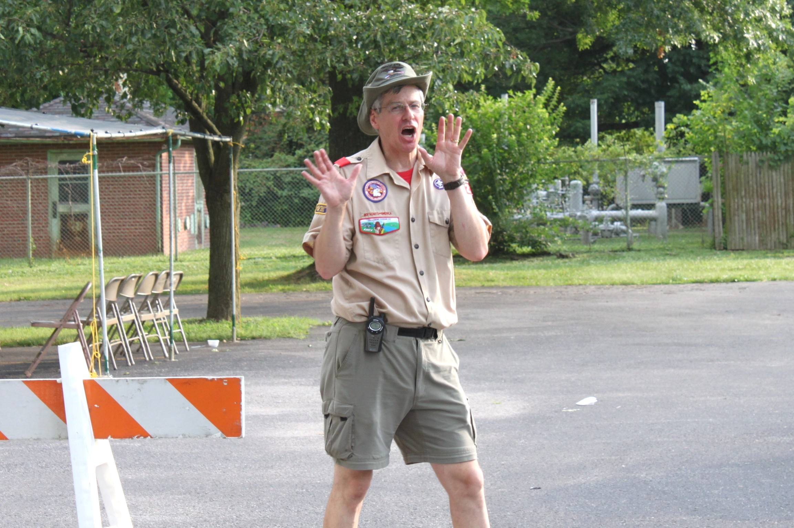
St. Barnabas Parish Picnic – If volume of cars parked is a measuring stick for the success of a parish picnic, the St. Barnabas 2010 parish picnic’s volume was certainly not down. As usual, Troop 243 deployed in full force in service to the parish that so generously hosts our troop in pretty much anything we ask them to do. Our new parking procedures that kicked in when St. Michaels built on their property is no longer a new procedure and worked like a charm again. And while we did not have as much space to use as we used to, St. Michaels Greek Orthodox Church generously supported St. Barnabas’ parking needs by letting us use the parking lots that they have. Canaan Baptist Church once again hosted more parking with the picnic paying for free bus service. Thanks to all who helped!
“There’s probably still spaces on the hill over yonder!” Jim Berger
“Get your free air-conditioned bus ride right here!” Tom Kennedy

Troop Leadership meetings – The PLC meeting will be held on August 29th at 4:00 at St. Barnabas. The adult meetings are scheduled for 7:00 and 8:00 on August 30th. All boys are invited to participate in the PLC and all adults are invited to join us for the adult leadership meetings.

Pictures! – Frank Hulsman will add any link you may have to troop pictures to the Troop 243 web site so we can all see them. If you have pictures on the net with a link we can access, send the link to Frank and he will add it to the Troop 243 web site. Our link: http://www.troop243.com/page.php?page=photos

Troop Gift Cards – Transportation to the vast majority of our outings is free to our scouts and leadership, but it is not free. The cost of maintenance, fuel and insurance for our bus is paid by the Friends of Troop 243 which is funded by the Kroger and Thorntons gift card programs. We encourage all parents, members, relatives and friends to use Troop 243’s Kroger and Thorntons gift cards. Whenever you see Frank Hulsman at any function it is likely that he has a few gift cards with him. Please stop Frank at any time and ask him for one of these cards and he will be glad to give you one.

Troop 243 Hosts Visiting Troop – The night of Wednesday August 4th, we will host a troop from Kansas who needed a place to crash for the night as they returned home from the Jamboree. As usual, St. Barnabas came through and gladly lent us the cafeteria as well as the facilities to cook the visiting troop breakfast. Thanks to Frank and Wayne for playing hosts!

Troop 243 Anniversary Court of Honor – We will celebrate our 41st anniversary at Creasy Mahan Nature Preserve on August 28th. We will gather for games at 4:00, Dinner around 5:30 and the Court of Honor around 7:00. Please bring a large vegetable, salad or desert to share and your own family’s drinks and chairs. Hamburgers, hot dogs, buns etc will be provided. http://www.creaseymahannaturepreserve.org/

Yours in Scouting,
Bruce Bohn
Troop Secretary

